Name: Devansh Shah

SYIT B2

1914078

Maths Prac 3

Q.1 Draw scatter diagram and determine the coefficient of correlation

|  |  |  |  |  |  |  |  |  |
| --- | --- | --- | --- | --- | --- | --- | --- | --- |
| Demand in quintals | 65 | 66 | 67 | 67 | 68 | 69 | 70 | 72 |
| Price in Rs er kg | 67 | 68 | 69 | 68 | 72 | 72 | 68 | 71 |

**Code:**

x=c(65,66,67,67,68,69,70,72)

y=c(67,68,69,68,72,72,68,71)

r=cor(x,y)

plot(x,y,main="scatter diagram",xlab="Demand",ylab="Price")

cat("coefficient of correlation is",r)

paste("name & roll no", "Devansh ,1914078")

**Output:**

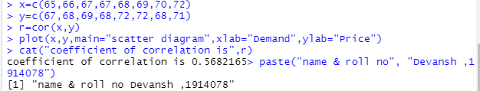

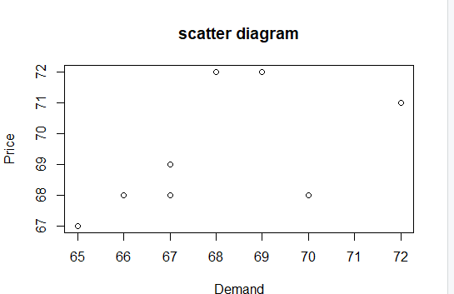

Q.2 Estimate the value of Y when X is 71

Plot equation of regression line of Y on X

|  |  |  |  |  |  |  |  |  |
| --- | --- | --- | --- | --- | --- | --- | --- | --- |
| Demand in quintals | 65 | 66 | 67 | 67 | 68 | 69 | 70 | 72 |
| Price in Rs per kg | 67 | 68 | 69 | 68 | 72 | 72 | 68 | 71 |

Ans.

**Code:**

x=c(65,66,67,67,68,69,70,72)

y=c(67,68,69,68,72,72,68,71)

r1=lm(y~x) # gives equation of of regression of y on x

co=coef(r1) # gives values of constants a,b in equation y=a+b*x

mco=matrix(co) # column matrix of constants a,b

a=mco[1,1]

cat ("constant term a is",a)

b=mco[2,1]

cat ("value of b is",b)

esty=fitted(r1) # gives estimated values of y for the given values of x

cat ("estimated values of y are", esty) # display estimated values of y for the given values of x

x1=71

ey=a+b*x1

cat ("estimated value of price for demand 71 is",ey)

plot (x,y,pch="+") # plots points corresponding to x and given value of y (+)

points(x,esty,pch="*") # plots points corresponding to x and it’s estimated value of y (*)

lines(x,y , col="green") # plots line corresponding to x and given value of y (+) using green colour

lines(x,esty , col="red")# plots line between x and estimated value of y (*) using red colour

paste("name & roll no", "Devansh ,1914078")

**Output:**

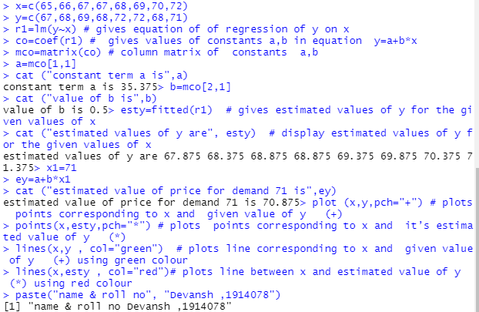

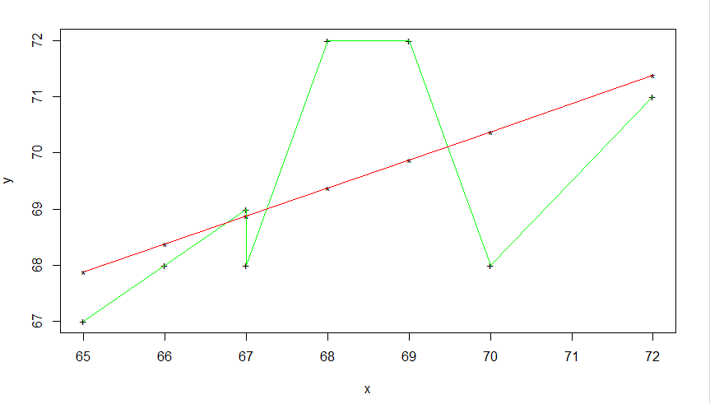

Q3 Estimate the value of X when Y is 27

Plot equation of regression line of X on Y

|  |  |  |  |  |  |  |  |  |  |  |
| --- | --- | --- | --- | --- | --- | --- | --- | --- | --- | --- |
| x: | 23 | 27 | 28 | 29 | 30 | 31 | 33 | 35 | 36 | 39 |
| y: | 18 | 22 | 23 | 24 | 25 | 26 | 28 | 29 | 30 | 32 |

Ans :

**Code :**

x=c(23,27,28,29,30,31,33,35,36,39)

y=c(18,22,23,24,25,26,28,29,30,32)

r1=lm(x~y) # gives equation of of regression line of x on y(i.e.x=a+by)

co=coef(r1) # gives values of a,b

mco=matrix(co) # column matrix of a,b

a=mco[1,1]

cat ("constant term a is",a)

b=mco[2,1]

cat ("value of b is",b)

estx=fitted(r1) # gives estimated values of y for the given values of x

cat ("estimated values of x are", estx) # display estimated values of y for the given values of x

y1=27

ex=a+b*y1

cat ("estimated value of X is",ex)

plot (x,y,pch="+") # plots points corresponding to x and given value of y (+)

points(estx,y,pch="*") # plots points corresponding to x and it’s estimated value of y (*)

lines(x,y , col="green") # plots line corresponding to x and given value of y (+) using green colour

lines(estx,y , col="red")# plots line between y and estimated value of x (*) using red colour

paste("name & roll no", "Devansh ,1914078")

**Output:**

